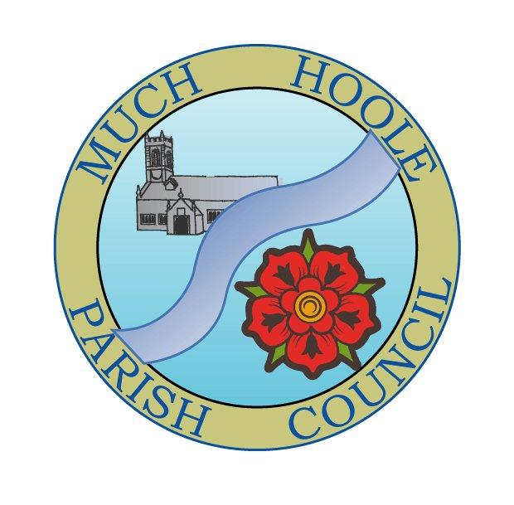 | MUCH HOOLE PARISH COUNCIL  NOTICE OF MEETING
You are hereby summoned to attend the Meeting of Much Hoole Parish Council to be held at 7.30pm on Monday 12th April 2021. The meeting will be held via Zoom video link under emergency powers in force due to the Corona virus legislation. Login details are shown below

PLEASE NOTE The Council meeting will be preceded by the Annual Parish Meeting starting at 7pm and may be delayed starting dependent on how long the Parish meeting takes.

Members of the public wishing to ‘attend’ the meeting may do so by using Zoom and the following login details:
Meeting ID: 750 3016 4166
Passcode: tvkkQ5

Russ Weaver, Clerk to the Parish Council

AGENDA
1. | Apologies for Absence  To receive apologies for absence.
2. | Declaration of Interests and Dispensations  - To receive declarations of interest from Councillors on items on the agenda  - To receive written requests for dispensations for disclosable pecuniary interests (if any)  - To grant any requests for dispensation as appropriate
3. | Minutes of the Previous Meetings  To resolve to approve as a correct record the Minutes of the Council Meeting held on the 8th March 2021.
4. | Public Time  To invite and listen to issues raised by members of the public.
5. | Off Road Cycle Track  To consider any updates on the Cycle track and resolve any actions required.
6. | Village Hall Update  To receive any updates on the village hall and progress towards its redevelopment.
7. | Finance  To resolve to authorise payment of the following:  - To resolve to pay Clerk’s salary for March 2021 in sum of £225.90 (net)  - To resolve to pay HMRC PAYE for March 2021 in sum of £56.10  - To resolve to pay the Clerk for mileage expenses for March in the sum of £13.05  - To resolve to reimburse the Clerk £201.18 for the purchase of the replacement plaque at the Trafalgar gardens. (This sum includes £33.53 in reclaimable VAT).  - To note the year end bank reconciliation as at 31st March 2021  - To note that the £500 annual payment to the Church for upkeep of the burial ground, as agreed at a previous meeting, has been placed on the banking system for authorization.
8. | Community Project update  To receive any updates on progress towards Installing the road signs
9. | Planning  There are no planning applications relating to Much Hoole since the date of the last meeting.
10. | Local Meetings  To receive reports or notification of any local meetings.  LALC Area meeting 23rd March 2021 attached
11. | Items for the Next Agenda (for information only)  Annual Parish Council meeting, election of Chair  To note and agree statement of governance and Internal audit report (if completed)  Adoption of General Power of Competence  Annual review of Clerk’s contract
12. | Date of Next Meeting  The Parish Council to agree the date of the next meeting which will be the Annual Parish Council Meeting..  The legislation allowing for virtual meetings expires on 7th May, but public meetings are not permitted until 17th May. The next scheduled meeting would fall on 10th May which is between these two dates, therefore, that date is not legally available as it cannot be held either virtually or physically. A new date is required.  OPTION 1. Bring the meeting date forward to 7.30pm Monday 3rd May (to be held virtually)  OPTION 2. Move the meeting date to on or after 7.30pm Monday 17th May on which date public meetings are due to be allowed, so this meeting could be held in the new village hall with suitable social distancing measures in place.

